FOR IMMEDIATE RELEASE: Tuesday, October 14th, 2014
CONTACT: Kristofer Eisenla, LUNA+EISENLA media
kristofer@lunaeisenlamedia.com | 202-670-5747 (mobile)

CIRCLE Releases 2014 Election Youth Data Toolkit
Ahead of November Election, CIRCLE Offers Data, Information and Analysis of Youth Voting Patterns and Behaviors

Medford/Somerville, MA – Heading into the November 2014 midterm election, the Center for Information and Research on Civic Learning & Engagement (CIRCLE) – the preeminent, non-partisan research center on youth engagement based at Tufts University’s Jonathan M. Tisch College of Citizenship and Public Service - today releases a midterm election toolkit – a compilation of previously compiled and distributed data and information on youth, youth voting patterns and engagement at your finger tips housed in CIRCLE’s 2014 Election Center.

Providing an in-depth understanding of the behaviors and voting patterns of young Americans, ages 18-29, the 2014 Election Center’s toolkit offers national, state-by-state and congressional district breakdowns of analysis and data relating to this important group of voters.

“Our 2014 Youth Election Center is a ‘one-stop shop’ for all things related to youth voting as we head toward Election Day,” said Peter Levine, director of CIRCLE. “Young voters, ages 18-29, continue to play a pivotal role in country’s elections. They were an influential constituency in both the 2008 and 2012 president elections, and have the opportunity to play that role again during this year’s 2014 midterm elections. It’s important that we have a clear understanding of who young voters really are, instead of the myths that too often define this critical voting block.”

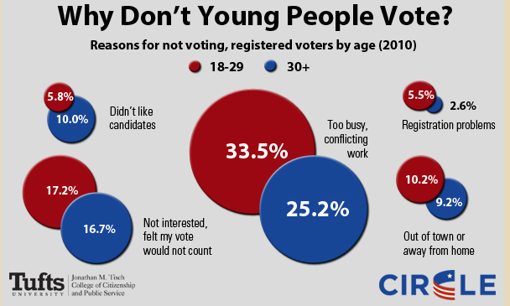

Some of the new products released this election cycle by CIRCLE’s researchers and analysts include:

- Interactive Congressional District Map -- The map features votes cast and population data on young people (ages 18-29) and older adults in each congressional district. The voting data includes statistics from the latest midterm (2010) and presidential (2012) elections. The map also displays district-level data on several economic, social, and demographic indicators, as well as a snapshot of which 2014 congressional races currently rank as competitive and select ballot measures in several states.

- Interactive State-by-State Voting Map -- The map includes data on youth voting and youth registration for the last three decades of presidential and midterm elections, as well as 2014 youth demographics for all states. You can also download a two-page “quick facts” sheet for each state and export the data in various formats.

- The Youth Vote in 2014: Congressional House Races to Watch – An in-depth analysis of top-targeted U.S. Congressional elections across the country where young voters could play a pivotal role. These races include Iowa-3, Arizona-1, Arizona-9, and New York -23.

- 2014 Midterms: Young Voters in Competitive Senate Races -- A handful of competitive races may decide which party has control of the U.S. Senate this November, and the data suggests that young voters could play an important role in these nationally watched contests. These races include Colorado, Kentucky, Alaska, Louisiana, Arkansas and North Carolina.

- Voting and Civic Engagement Among Youth of Color -- This new analysis provides a comprehensive overview of the ways in which African-American, Latino and Asian-American youth engage in our country’s political and democratic process. Among other key points, this new set of fact sheets illustrate: the rates of voter registration, voter turnout, and reasons for not voting and registering among these groups of young people.

CIRCLE is well known for producing unbiased analysis on youth voting in every election cycle. In addition to providing publicly released products, CIRCLE’s team of experts are also available to help put current data on youth voters and politics into a broader context based on their own research and knowledge of scholarly literature on the subject area.

Additional products and background analysis on the voting patterns and behaviors of young voters previously released by CIRCLE, include:

- Why Half of Youth Don’t Register to Vote
- How Youth Register to Vote
- Why (Some) Registered Youth Don’t Vote
- Lessons from the 2010 Elections about Turnout among Registered Youth
- Lack of Information and Engagement Make Presidential and Midterm Years Different for Youth

** To speak to one of CIRCLE’s youth vote experts or for further information on youth voters in America, please contact Kristofer Eisenla at kristofer@lunaeisenlamedia.com or 202-670-5747**

###

CIRCLE (www.civicyouth.org) is a nonpartisan, independent, academic research center that studies young people in politics and presents detailed data on young voters in all 50 states. CIRCLE is part of the Jonathan M. Tisch College of Citizenship and Public Service at Tufts University.

The Jonathan M. Tisch College of Citizenship and Public Service (http://activecitizen.tufts.edu/) is a national leader whose model and research are setting the standard for higher education’s role in civic engagement education. Serving every school of Tufts University, Tisch College creates an enduring culture that prepares students to be lifelong active citizens.

Tufts University (http://www.tufts.edu/), located on three Massachusetts campuses in Boston, Medford/Somerville and Grafton, and in Talloires, France, is recognized as one of the premier research universities in the United States. Tufts enjoys a global reputation for academic excellence and for the preparation of students as leaders in a wide range of professions. A growing number of innovative teaching and research initiatives span all Tufts campuses, and collaboration among the faculty and students in the undergraduate, graduate, and professional programs across the university’s schools is widely encouraged.

