FOR IMMEDIATE RELEASE: Monday, September 22nd, 2014
CONTACT: Kristofer Eisenla, LUNA+EISENLA media
kristofer@lunaeisenlamedia.com | 202-670-5747 (mobile)

Arkansas U.S. Senate Election: New Analysis Shows Youth Vote Could Play Key Role
Dynamic, Online Map Allows Viewers to Gain a Comprehensive View of Young Voters in Arkansas and the Nation

Medford/Somerville, MA – The Center for Information and Research on Civic Learning & Engagement (CIRCLE), the nation’s premiere source of nonpartisan information on youth voting, which is based at Tufts University’s Tisch College of Citizenship and Public Service, released a new, interactive online map with detailed data on young voters in every state, including Arkansas, since 1982. Today’s release by CIRCLE is also accompanied by an analysis of youth voters in Arkansas as compared to national trends, available here.

The analysis released today by CIRCLE shows that youth could play a key role in November’s hotly contested U.S. Senate election in Arkansas. Incumbent U.S. Senator Mark Pryor (D-AR) is defending his seat in this nationally watched election. Young Arkansans – ages 18-29 – make up 19.5% of the citizen population.

Young people cast 124,000 votes in the last mid-term election back in November of 2010. The margin of victory in the 2010 mid-term U.S. Senate election was 163,462.

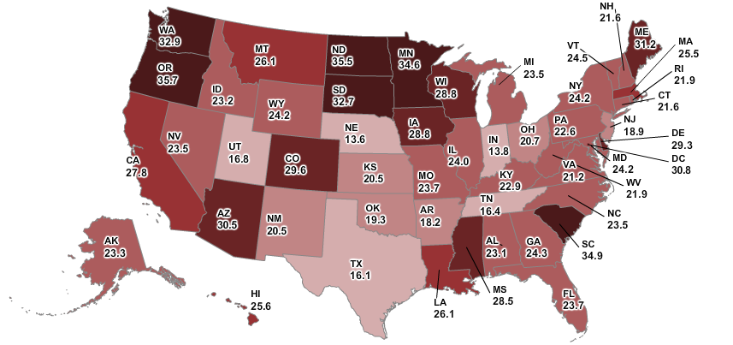

Click here or above for access to the interactive map

“In this year’s U.S. Senate race in Arkansas, youth voters have the ability to make a significant impact,” said Peter Levine, director of CIRCLE. “As we enter the 2014 midterm election season, we’re offering the public and the media a place to find the most up-to-date, comprehensive data on young Americans in an easily searchable format.”

Some of the key findings of the analysis drawn from CIRCLE’s newly released interactive, online map about the youth vote in Arkansas include:

- There are approximately 407,000 young citizens in the state, ages 18-29;

- In the 2010 mid-term election, young people made up 8% of all votes cast in that election (124,000 votes);

- Youth voter turnout has been around 20% during the last three midterm cycles (21.2% turnout in 2006, 18.2% turnout in 2010);

- 52.5% of young Arkansans (18-29) do not have college experience, which is much higher than the national rate (40.1%).

CIRCLE’s online “2014 Election Center” houses analysis and findings most relevant to the midterm elections. CIRCLE is well known for producing unbiased analysis on youth voting in every election cycle. In addition to publicly released products, CIRCLE’s team of experts are also available to help put current data on youth voters and politics into a broader context based on their own research and knowledge of scholarly literature on the subject area.

** Throughout the 2014 midterm election season, please contact Kristofer Eisenla at kristofer@lunaeisenlamedia.com or 202-670-5747, to speak to one of CIRCLE’s youth vote experts or for further information/data on the youth vote in America **

###

CIRCLE (www.civicyouth.org) is a nonpartisan, independent, academic research center that studies young people in politics and presents detailed data on young voters in all 50 states. CIRCLE is part of the Jonathan M. Tisch College of Citizenship and Public Service at Tufts University.

The Jonathan M. Tisch College of Citizenship and Public Service (http://activecitizen.tufts.edu/) is a national leader whose model and research are setting the standard for higher education’s role in civic engagement education. Serving every school of Tufts University, Tisch College creates an enduring culture that prepares students to be lifelong active citizens.

Tufts University (http://www.tufts.edu/), located on three Massachusetts campuses in Boston, Medford/Somerville and Grafton, and in Talloires, France, is recognized as one of the premier research universities in the United States. Tufts enjoys a global reputation for academic excellence and for the preparation of students as leaders in a wide range of professions. A growing number of innovative teaching and research initiatives span all Tufts campuses, and collaboration among the faculty and students in the undergraduate, graduate, and professional programs across the university’s schools is widely encouraged.

